SVN installation

<https://help.ubuntu.com/community/Subversion>

<https://blogsai.wordpress.com/2011/05/31/how-to-setup-reviewboard-for-code-reviews-on-your-ubuntu-os/>

https://blogsai.wordpress.com/2011/05/31/how-to-setup-reviewboard-for-code-reviews-on-your-ubuntu-os/

https://help.ubuntu.com/community/Subversion

sudo apt install subversion

mkdir -p *REPOS_PATH*

svnadmin create *REPOS_PATH*

sudo apt-get install tree

sudo nano path_to_repo/conf/svnserve.conf

auth-access = write

password-db = password

sudo nano path_to_repo/conf/passwd

create user

username = password

eg saurabh = password

groupadd name_of_group

useradd name_of_user -g groupname

passwd name_of_user

groups name_of_user

chown -R name_of_user:name_of_group /path/to/repo

chmod -R 770 /path/to/repo

sudo -u name_of_user svnserve -d -r /path/to/repo

nstat -ltp |grep -e PID -e “svn”

sudo apt-get install default-jdk

svn import . file:///path/to/repos --message 'Initial repository layout'

nessecery to run for use exery time or add it to init...

svnserve -d --foreground -r /home/svn

### **Download and install Eclipse**

You only need to do this once.

1. Browse to [eclipse.org](http://eclipse.org/)
2. Click **Downloads**.
3. Select a download package, which will be a compressed file. Unless you have specific needs that lead you to another package, the Eclipse Classic version is usually a good choice.
4. Extract the files from your download. The executable file **eclipse.exe** will be included.

Continue with the next section, **Install the Subclipse Plugin**.

### **Install the Subclipse Plugin**

You only need to do this once, after downloading Eclipse.

1. Run **eclipse.exe**. (The first time you run Eclipse, it will ask you where to keep your local files. Accepting the default is usually fine.)
2. From the **Help** menu, select **Install New Software**.
3. Click **Add** (near the upper-right corner of the dialog box).
4. In the **Add Site** dialog box, for the **Name**, enter Tigris
5. For **Location**, enter http://subclipse.tigris.org/update_1.4.x
6. If a dialog box asks which components to install, just select the ones marked **required**.
7. (You may need to expand the three branch "Subclipse" to see the required components.)

Eclipse is now ready for you to define connections to your repositories.

### **Add a connection (to your repository) to Eclipse**

You will need to do this once for each Subversion repository. This section includes the initial creation of local copies of your repository files.

1. Open the **Subversion Repository Exploring** perspective. If you do not see a button for this perspective, from the **Window** menu, select **Open Perspective**, then **Other**, then select **SVN Repository Exploring** and click **OK**.
2. 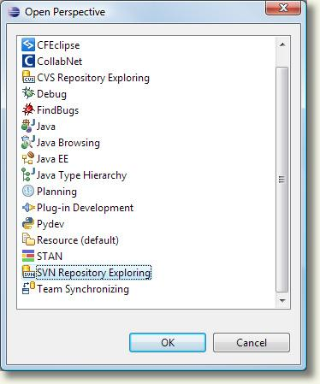
3. Right-click in the **SVN Repository** view and select **New**, then **Repository Location**.
4. 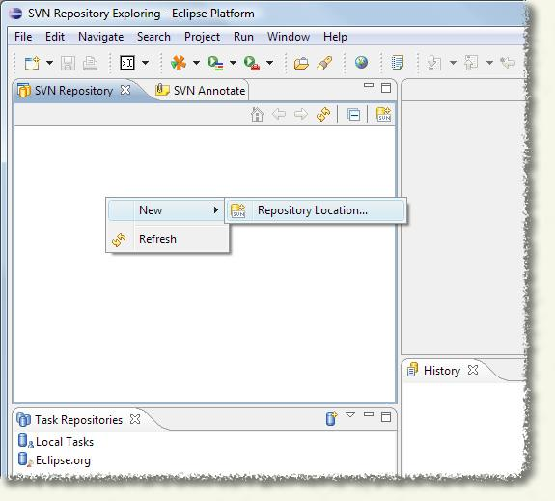
5. In the **Add SVN Repository** dialog box, for **Location**, enter the TeamForge repository URL, then click**Finish**.
6. ([How do I know what my repository URL is](http://www.it.cornell.edu/services/subversion/howto/access-geturl.cfm)?)
7. 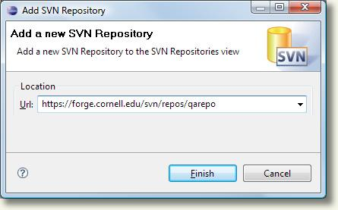
8. You may be prompted to accept the TeamForge certificate. If so, click **Accept Permanently**.
9. 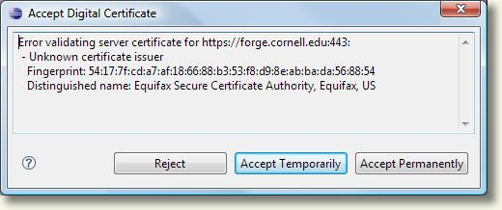
10. In the **Enter Username and Password** dialog box, enter your TeamForge user name and the**TeamForge login** password. ([How do I know what my TeamForge password is?](http://www.it.cornell.edu/services/teamforge/howto/users/setpassword.cfm)) Check **Save Password** to save your password so that you are not repeatedly prompted.
11. Note: You CANNOT use your Cornell single sign-on credentials (your NetID and related password).
12. 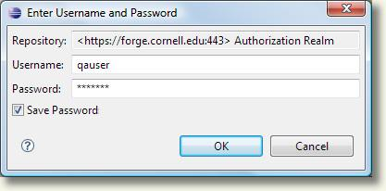
13. Click **OK**. At this point the Subversion repository should listed in your SVN Repository view and should be browsable.
14. 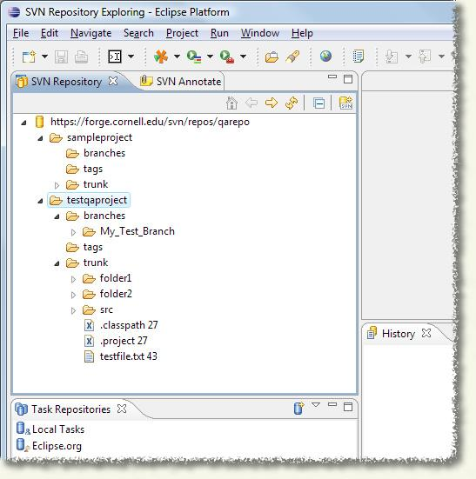

For information on how to use your repository, refer to your Subversion client tool's documentation.